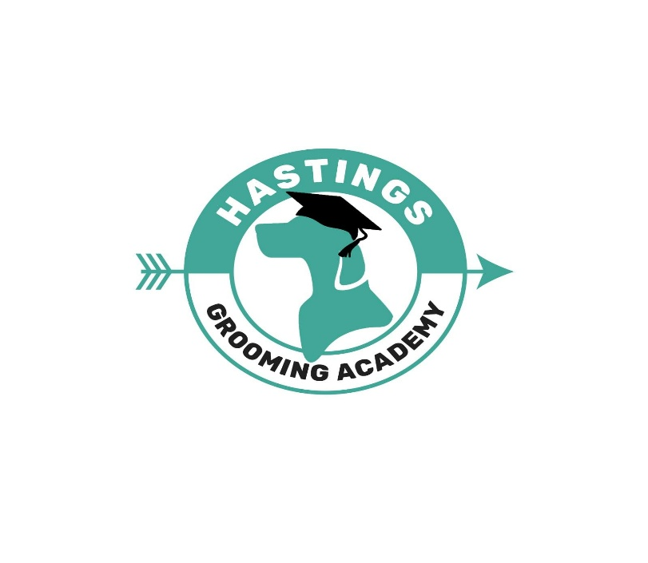
Enrolment form
Name:
Address:

D.O.B
Telephone:
Mobile:
Email:
Ethnicity:

Which course would you like to enrol for?
(Please circle or highlight)

City & Guilds Level 2 - 22 day course
Practical Grooming course – 20 day
Level 3 SEG including Emmi Pet - 25 day.Course
City & Guilds Combined 2&3 - 40 day course
City & Guilds Combined 2&3 – 40 day including Emmi pet training & kit
Taster day/groom your own dog day - 1 day course
OCN first aid course - online course

How did you hear about gillsmans dog grooming academy?

…………………………………………

Which days would you like to do or have been allocated to you by the school?
(Please circle or highlight)

Thursday, Friday, Saturday

Do you have any learning difficulties or disabilities that may affect your learning during the course? Please state any conditions below

Which kit would you like to purchase?

Standard kit
Upgrade kit (included in all inclusive)

Are you left or right handed?

What top size do you require for your grooming smock?
(Please circle or highlight) XS, Small, Medium, Large, Extra Large, xxl, xxx6 8 10- 12 12-14 14 16 18
Grooming smocks come up very small

Please contact for bank details of how to pay a deposit to hold your course! Your course position will Not be held until the deposit has been paid.

